Figure S2. Three-step matching algorithm
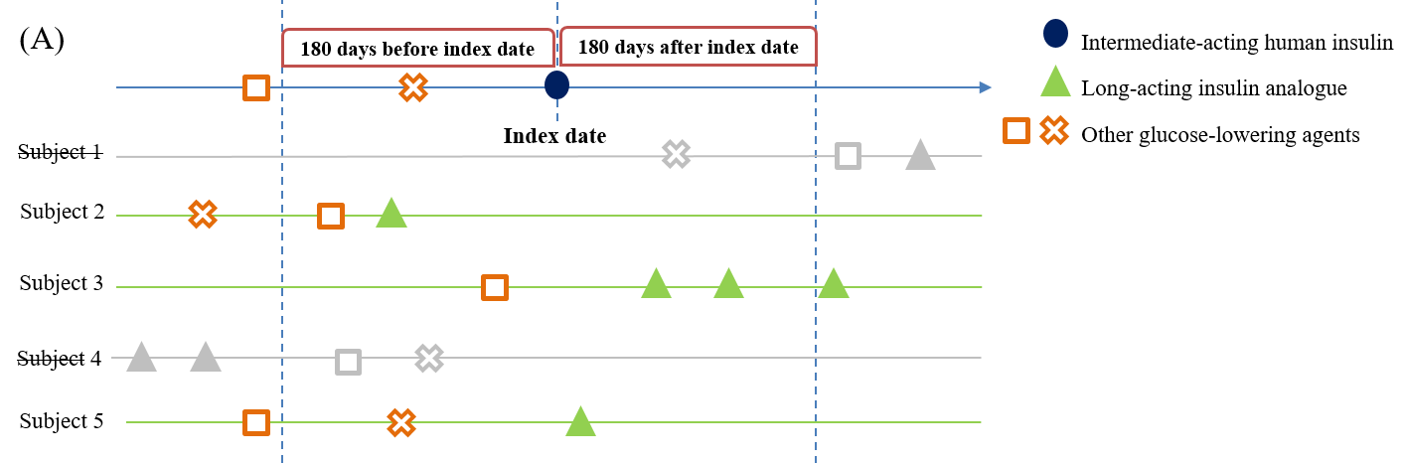

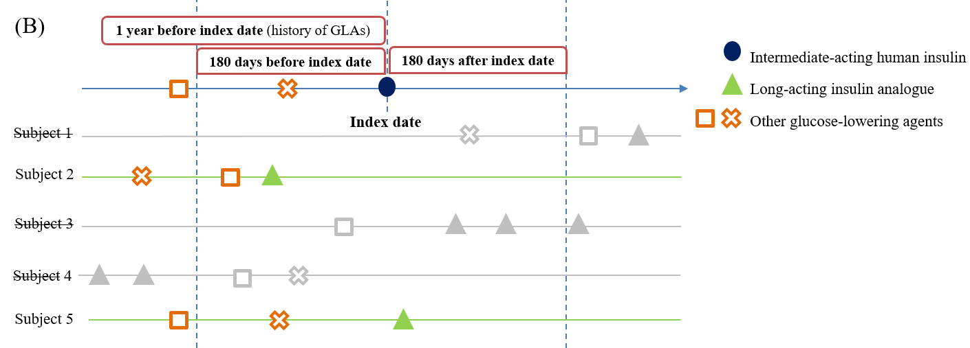

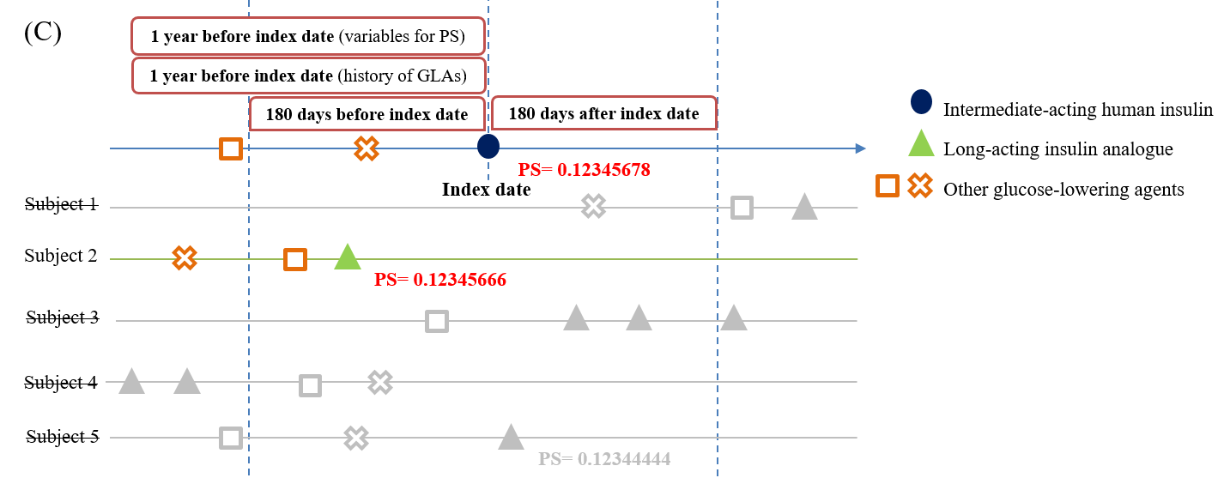

- The first step was to match the index date with the pre-defined time interval (i.e., ±180 days). For example, there were five subjects that used the comparator drug (long-acting insulin analogue) for one subject that used the study drug (intermediate-acting human insulin). Subject 1 and Subject 4 were excluded because their index dates were not in the time interval.
- The second step was to match the previous utilization patterns of glucose-lower agents (GLAs). Subject 3 was excluded due to the different utilization patterns of GLAs prior to using the comparator drug.
- The third step was to match the propensity score based on baseline subject characteristics measured from the year before or at the index date. The propensity score of Subject 2 was closest to that of the study drug subject, and thus Subject 2 was selected as the matched comparator drug subject.

